October 17, 2024

Muslim Mortuary and Cemetery Committee
13121 Brookhurst St., Unit C
Garden Grove, CA 92843
c/o Hamid Haque

Hunsaker & Associates
3 Hughes
Irvine, CA 92618
c/o Robert Glessner

EPD Solutions
3333 Michelson Dr., Suite 500
Irvine, CA 92612
c/o Norah Jaffan

RE: CONDITIONAL USE PERMIT NO. 230002 “Crescent Gardens Cemetery”

REQUEST: Conditional Use Permit No. 230002 is a proposal for the construction of a cemetery (25 acres of gravesite), mortuary, chapel, equipment shed, and caretaker manager residence.

Your proposal was scheduled for comments from the Development Advisory Committee (DAC) on October 17, 2024. Enclosed are the resulting comments from the Riverside County Planning Department and all other available comments and recommended Conditions of Approval.

Planning Department Corrections: The corrections listed below are REPEAT CORRECTIONS and must be updated before plan approval. Review all charts, matrices, square footages, and calculations, for consistency across all plans.

- Provide a project description. Include the business plan, hours of operation, number of employees, etc. Include a detailed narrative of the operations plan including the burial process.

- Review the “ Filing Instructions for the Use Permit,” and include all information required for a Conditional Use Permit (CUP) required on the exhibit. For example, Current/ proposed zoning is missing. Please review the informational portion of the exhibits for completeness.

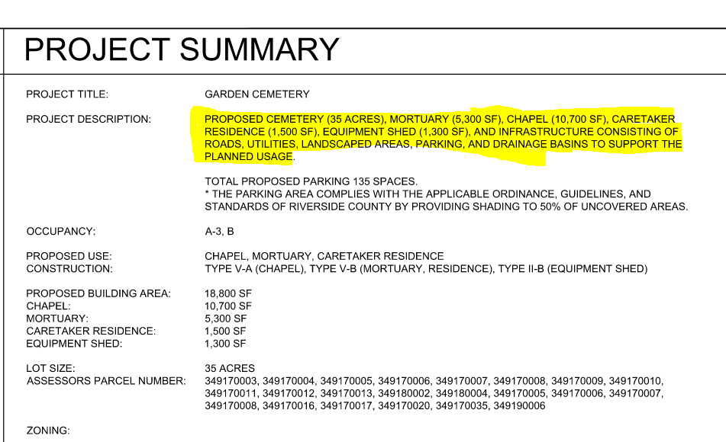
- Repeat Correction -- Correct the Project Description on page A0.01 (“Project Information” page). The square footages of the structures provided on the Site Plan exhibit do not match those provided in the description.

- Repeat Correction -- Update the total parking space counts on page A0.01 (“Project Information” page) so they are consistent with those listed on the Site Plan. The proposed number of spaces are different amounts.

Sheet C-6: VS. Sheet A0.01:
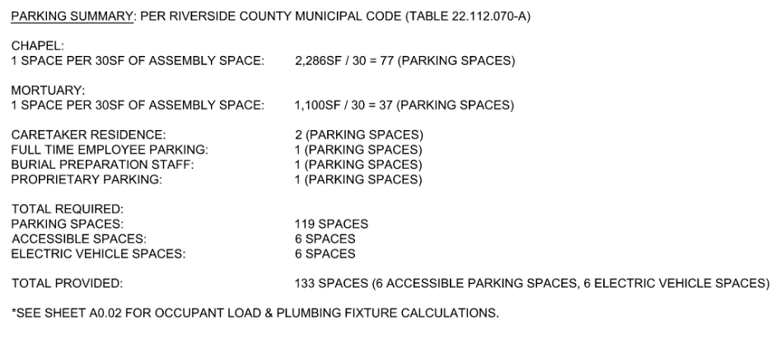
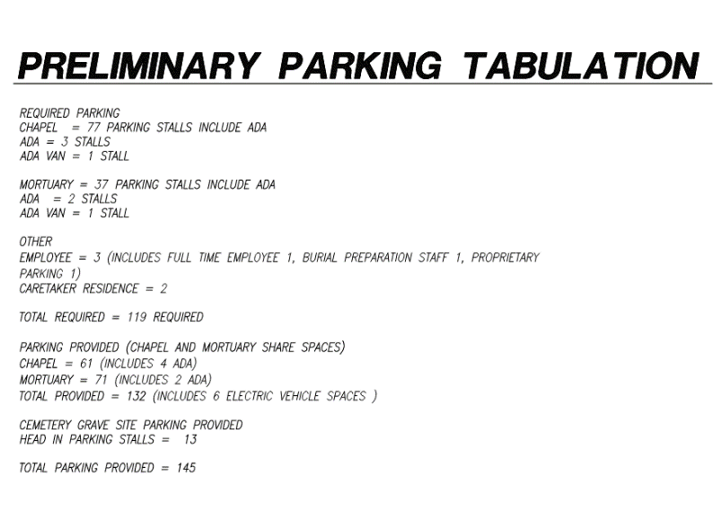

- Parking calculation chart, please provide breakdowns that match our Ordinance so we can verify compliance- these calculations shall match and show consistency across all plans:

  - cemeteries and crematories, mausoleums, columbarium, and funeral establishments when incidental to a cemetery:

    - 1 space/30 sq. ft of net assembly room area
      - Provide the separate square footage of the net assembly area for the mortuary and the net assembly area for the chapel, and calculate the number of parking spaces you’d need for each building based on this calculation
    - 1 space/employee
    - 1 space/vehicle operated on the grounds by the proprietary institution

- Review the square footage for each building and ensure the numbers on the footprint match the square footage in the building calculation chart or matrix.

- Repeat Correction: Provide a visual example of the F3 lighting proposed on-site so it can be verified that it’s meeting lighting standards.
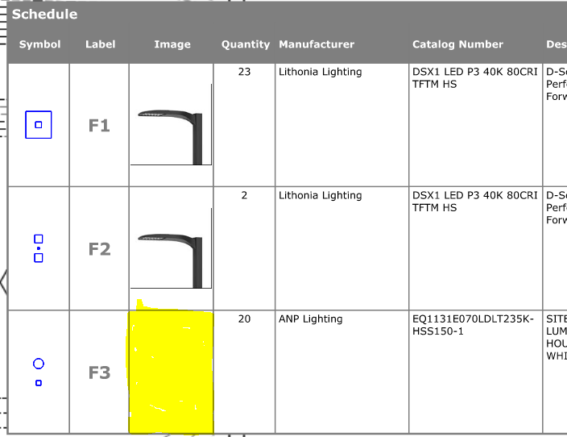

- Provide a summary of the result of your conversation with the District 1 Supervisor’s Office on your Environmental Justice Community Checklist. Please identify any corrections that were requested, or if you received clearance from the District that the checklist is approved.

Development Advisory Committee Comments:

Your case has been CLEARED by the following Departments:

ENVIRONMENTAL HEALTH
FIRE
GEOLOGY
GRADING
TRANSPORTATION -DEVELOPMENT REVIEW
TRANSPORTATION- TRAFFIC STUDY
TRANSPORTATION- WQMP
TRANSPORTATION-LANDSCAPE
PALEONTOLOGY
WASTE RESOURCES

Your case has been given CORRECTIONS by the following Departments:

BIOLOGY
CULTURAL
FLOOD CONTROL
PLANNING

Your case has reviews that are still PENDING by the following Departments:

BUILDING & SAFETY – PLANCHECK

The following DAC Members can be contacted at:

Transportation – PlanCheck & Traffic Study: (951) 955-6527
Transportation – WQMP: (951) 955-6769
Grading: (951) 955-6748
Landscape: (951) 955-6767
Fire Dept. Receptionist: (951) 955-4777
Geology & Paleontology: (951) 955-6187
County Archaeologist: (951) 955-2873
Environmental Programs Division (Biology): (951) 955-6441
Dept. of Building & Safety-Grading and Plan Check: (951) 955-2559
Environmental Health Dept. Receptionist: (951) 955-8980
Waste Resources: (951) 486-3200
Flood Control District Receptionist: (951) 955-1200
Current Planning – Kathleen Mitchell: (951) 955-6836

Exhibits:

Once all comments and/or clearances have been received from these departments, please submit amended maps/site plans, elevation, floor, and landscaping plans, reflecting any requests, comments, and requirements, along with a response letter addressing each comment.

Final Comments:

Substantial revisions to the proposal after issuance of this letter, which do not conform to the comments of the letter, will invalidate the letter and a complete review will be required. Furthermore, failure to submit all required corrections, documentation, and special studies as described in the contents of this letter will slow down the review process. After site plans are amended, the project representative will make an appointment to resubmit a complete application package to the Project Planner, including all special studies, and fees.

Please address any Planning Department questions or concerns to kmason@rivco.org or call (951) 955-1722. Questions concerning other departments should be addressed to the individuals listed on the phone list provided.

As a note, be aware that prior to scheduling this project for a public hearing, all property tax assessments associated with this project must be paid.

Sincerely,

RIVERSIDE COUNTY PLANNING DEPARTMENT
John Hildebrand, Planning Director

Krista Mason, Project planner

